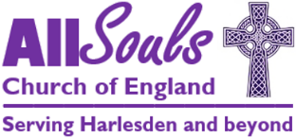

**Charity Gift Aid Declaration**

multiple donation

**Boost your donation by 25p of Gift Aid for every £1 you donate**

Gift Aid is reclaimed by the charity from the tax you pay for the current tax year.   
Your address is needed to identify you as a current UK taxpayer.

**In order to Gift Aid your donation you must tick the box below:**

I am happy for all gifts of money that I have made to All Souls Parochial Church Council in the past 4 years and all future gifts of money that I make to be Gift Aid donations. All Souls PCC will reclaim 25p of tax on every £1 I give.

**Donor’s details:**

Title……………………….. First name/Initial……………………………………….………………

Surname…………………………………………………………………………………………….....

House No/Name……………………..…..…………………………………………………………….

Address…………………………………………………………………………………………………

…………………………………………………………………………………………………………

Postcode…………………………………………………….

I am a UK taxpayer and understand that if I pay less Income Tax and/or Capital Gains Tax than the amount of Gift Aid claimed on all my donations in that tax year it is my responsibility to pay any difference.

**Signed** ____________________________

**Date** ____________________

**Please notify the charity if you:**

* Want to cancel this declaration
* Change your name or home address
* No longer pay sufficient tax on your income and/or capital gains

If you pay tax at the higher rate you can claim further tax relief   
in your Self-Assessment tax return.

**Please send this form to:**

All Souls PCC Treasurer, Station Road, London, NW10 4UJ

or email to: [allsoulsharlesden@gmail.com](mailto:allsoulsharlesden@gmail.com)

Charity Commission Registration Number: 1131170